Assignment #9 Advance Charts by Joshua Troup

1. Heat Maps: Ideal for comparing categorical data (using color and size)

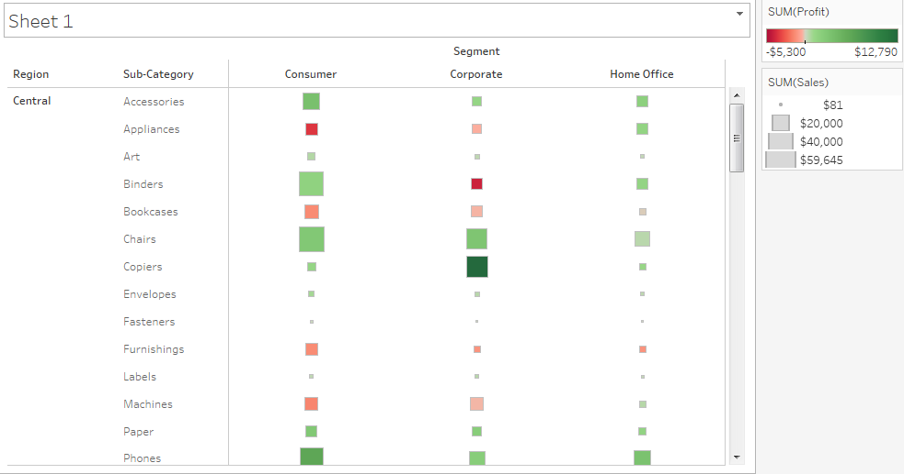

1. Bubble Charts:

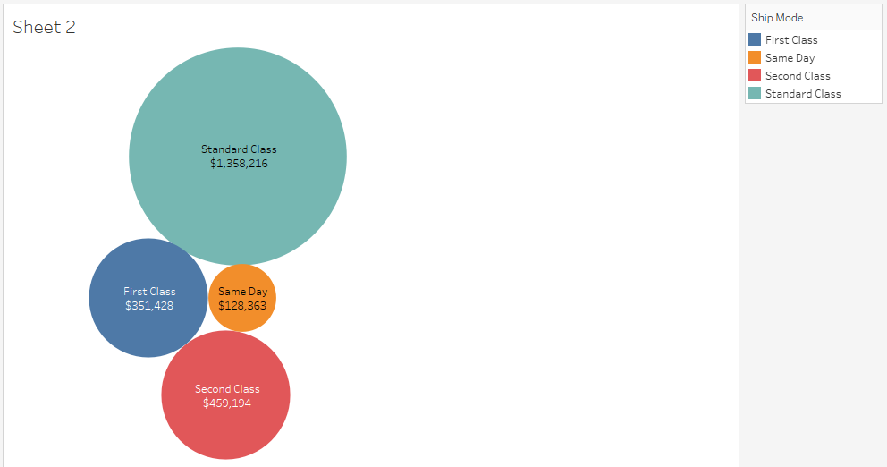

1. Bullet Charts:

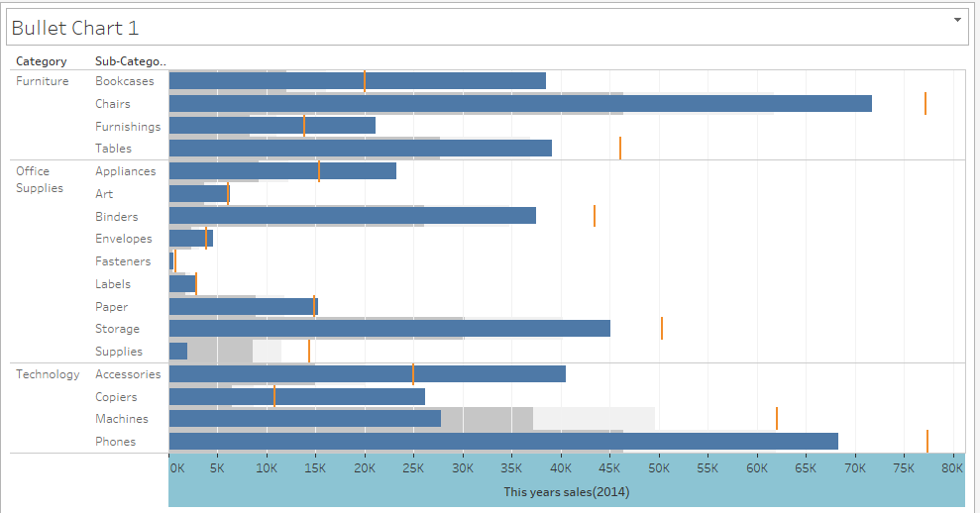

1. Pareto Chart (80/20 Rule)

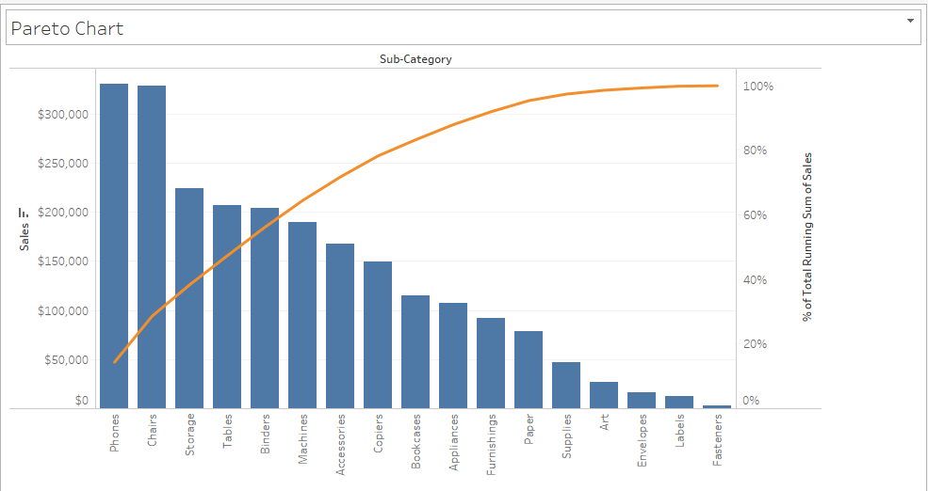

4a. Explore Pareto chart to look at which product sub-categories in Sample -Superstore contribute the most returned items. • Comment on the “three most returned” product subcategories and what % do they contribute? • With this insight, as a decision maker, what will be your action?

**The three most returned product subcategories are the following:**

**Binders—17.13%**

**Paper—32.50%**

**Phones—42.13%**

**As a decision maker, I would investigate the supplier or manufacturer of these three items to determine if the product is faulty or not up to specs. I would also consider the returns may come from customers who find better prices from our competitors. I would encourage promotions to increase volume and decrease returns.**

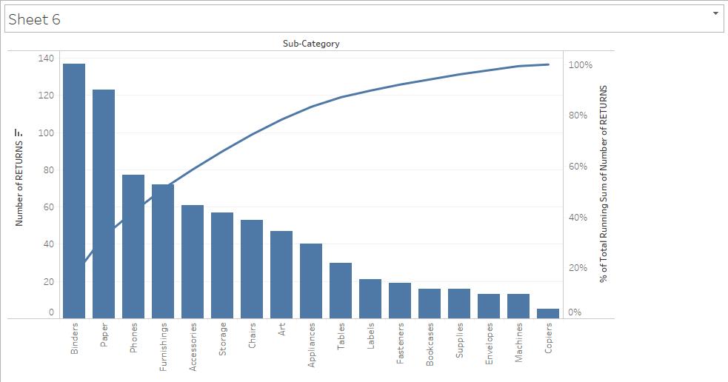

1. Tree maps

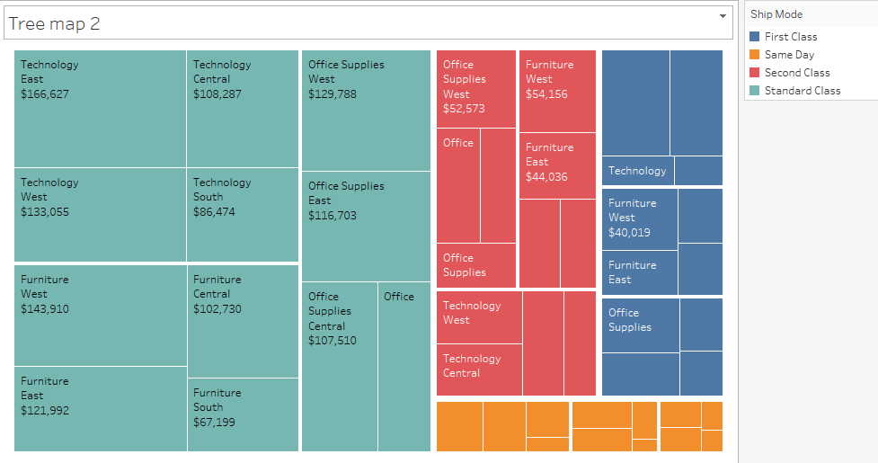

**The shipping method is color coordinated shown above. The size of the rectangle is based on the sales amount. Bigger sales = bigger rectangles. The map above tells us standard class is the most popular method of products with the highest sales values.**

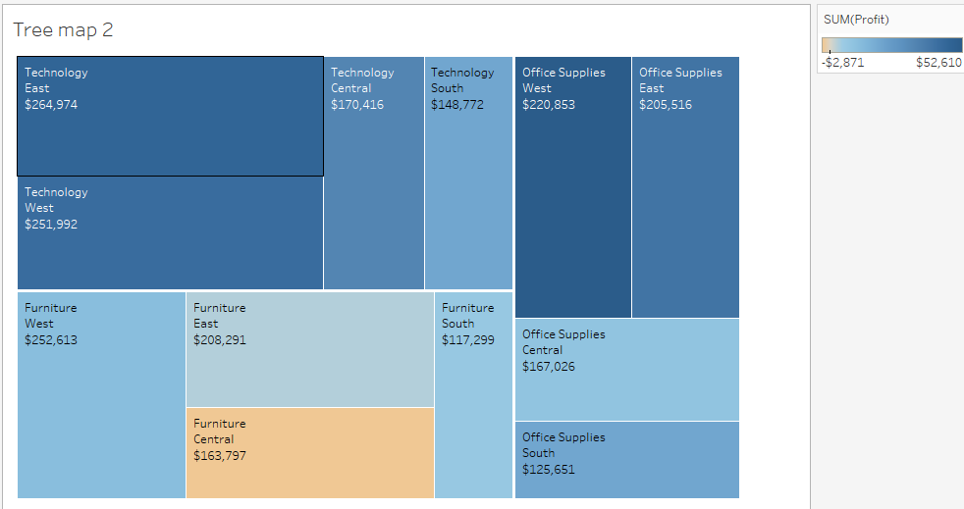

**Profit amount is based on size of rectangle. Technology and furniture seem to be the highest selling products and greatest profit return. Furniture central does show a negative (tan color) profit.**

1. GANTT Charts

